

Job Description:

Glasgow Film Festival 2027 Marketing Officer

October 2026
Glasgow Film Festival (GFF) is Scotland’s flagship film festival and 2027 will be its 23rd edition. Showcasing a programme of world, European, UK and Scottish premieres, the 12-day, award-winning festival is a celebration of the best Scottish and international filmmaking, and gives film fans the chance to attend Q&As with film talent, both local and international. GFF also runs an agenda-setting five-day Industry conference for delegates at all stages of their career, plus a range of free and discounted screenings, community and youth workshops, and pop-up immersive events.

GFF’s Marketing Team play a crucial role in making sure the festival reaches a wide audience, and the wide variety of films and events are effectively promoted.

Who are we looking for?

This role requires someone with broad experience in marketing, including social media, direct mail (newsletters) and promotional print assets, as well as an understanding of the different platforms best suited to different audiences and content.

The successful candidate will also be organised and proactive, willing to bring ideas and problem-solving skills to the team, and confident in multi-tasking and meeting deadlines. Working as part of a skilled and experienced team, the Marketing Officer will support colleagues in several roles, as well as having responsibility for key areas of work.

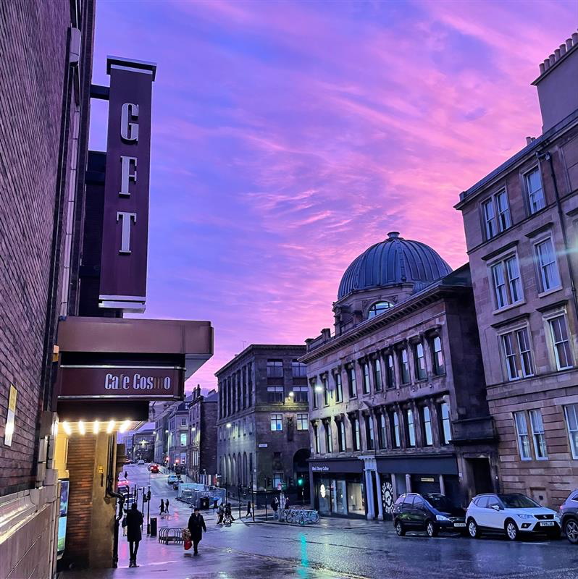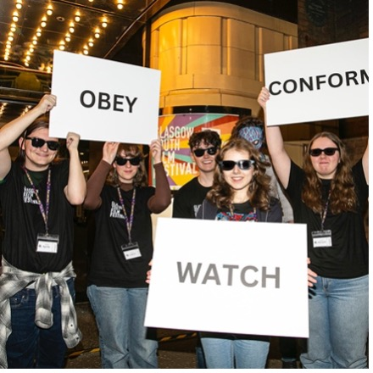

Glasgow Film is funded by
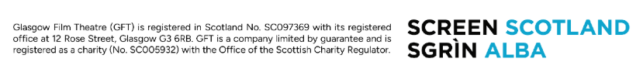
Information for applicants:
October 2026
Dear Applicant,
Thank you for your interest in the post of Marketing Officer at Glasgow Film Festival.
In this pack, you will find some background information about Glasgow Film, along with more detailed information about the role, a job description, a person specification, and broad terms and conditions.
If you would like to apply for the post, please complete:
- The online application form here
- The online equal opportunities monitoring form here
Please refer to the job description and person specification in your application, telling us why you are interested and what skills and experience you would bring to the role. Please note that, in line with our environmental policy, we are only handling applications electronically.
The closing date is Monday 26 October at 10:00 am and interviews will be held online w/c Monday 2 November.
We look forward to hearing from you and thank you again for your interest.

Debbie Aitken

Head of Operations for Glasgow Film Festival
Glasgow Film

About Glasgow Film
Visiting Glasgow Film Theatre feels like stepping into another world. Since 1939 our iconic picture house has been a jewel in the crown of Glasgow’s cultural offering: a purpose-built cinema in the heart of the city, created for the most enthusiastic filmgoers on the planet.
Under the stewardship of Glasgow Film for half a century, our screens show new releases, thematic seasons, rarely screened classics and undiscovered gems, expertly curated by our in-house programming team. Alongside our many programming partners we champion underrepresented filmmakers as well as all-too-often overlooked cinema from around the globe. We have meticulously modernised our film technology whilst honouring our rich cinema heritage and our commitment to the unique craft of 35mm and 70mm film projection. We’ve invested in a world class film-going experience including vital accessibility features to support all audiences and our refurbished art deco interiors make every casual visit feel like an occasion.
As a registered educational charity since 1986, Glasgow Film has evolved from a single screen cinema into a thriving three screen hub of activity where children, families, and young people can learn about film, communities can come together, and filmmakers of the future can develop their careers. In 2024 we celebrated our 50th birthday and held the 20th edition of the renowned Glasgow Film Festival, a legacy that has widened our international reach and helped to nurture our dedicated and diverse film going community that celebrates cinema in all its technicolour (and monochromatic) glory.
We offer something truly special, an inclusive and welcoming space where everyone can nurture their passion for film, delivered by a passionate and knowledgeable team who believe in Cinema for All. We exist to celebrate the magic of film and without us, independent cinema in Scotland would be greatly diminished, losing much of its depth and diversity. People from all walks of life join us to experience films, both new and classic, the way they were meant to be.

Glasgow Film is:
GFT (Glasgow Film Theatre), Glasgow’s original independent cinema.
Glasgow Film Festival (GFF), the UK's second-largest film festival, taking place from 24 February - 7 March 2027.
Glasgow Youth Film Festival (GYFF), our annual youth film festival, co-programmed by a group of Young Programmers aged 15 to 18.
Learning and Youth Opportunities providing children, young people and teachers with the tools and opportunities to get involved in Glasgow’s film culture.
Film Hub Scotland supporting a network of more than 250 film exhibitors serving Scotland's diverse population.

Vision & Mission:
Our vision for Glasgow Film is an inclusive, collaborative space where audiences and communities can nurture their passion for cinema and film and be empowered through participation in our programmes. Everyone is welcome and everyone is included. This is ‘Cinema For All’.
Our mission is to provide 'Cinema For All'. We exist to celebrate the magic of film and nurture excellent independent cinema from across the globe. To do this we provide high-quality programmes of curated screenings, festivals, events and industry opportunities; we empower our communities to participate through education and outreach initiatives; and we develop sector leading equalities initiatives to ensure cinema is accessible, safe and welcoming for the widest possible audience.
Our values are:
Community
This means that we will value, nurture and grow the Glasgow Film community of film fans, staff, supporters, industry and young people. We will have a positive impact in our community and build meaningful relationships with local people and local organisations as well as national and international networks. We will prioritise equality of access and work to tackle the consequences of systemic racism and inequalities that negatively impact the screen sector and fair access to the arts and culture.
Authenticity
This means we are genuine, honest and transparent with our audiences, our stakeholders and with each other as colleagues. We will behave ethically, with purpose, mindfulness and integrity in our everyday activities. We will celebrate our important history and strong identity. We know who we are, and our mission and purpose is clear.
Sustainability
This means we will future proof Glasgow Film for future generations through strong governance, expanding the diversity of our communities and reducing our carbon impact. We will continue to learn how to work more sustainably and imbed good environmental practices across all areas of our organisation.

Equity, Diversity and Inclusion at Glasgow Film
Glasgow Films’ commitment to equity, diversity and inclusion is clearly stated in our vision: Cinema For All. We have a proud history and track record of diverse programming, equalities driven partnership working and developing sector leading equalities initiatives (particularly for disabled audiences). Our flagship initiatives are informed by the views of those with lived experience and we understand that discrimination and inequality affect people in complex ways. Our Equity and Anti-Racism Strategy (led by the Executive) guides our priorities, and our programme and engagement activities play an important part in the success of this strategy.
Information on our community engagement and flagship equalities initiatives can be found here.
Glasgow Film organises annual equalities training for staff and volunteers.
Glasgow Film has a Staff and Volunteers Diversity Committee which meets quarterly.

Job Description: Glasgow Film Festival 2027 Marketing Officer

Terms and Conditions

Employer: Glasgow Film Theatre

Salary: £29,490 (pro-rata)

Term: Fixed term contract from 30 November 2026 to 26 March 2027

Hours: Full time - 35 hours per week
The role may require occasional work outside of normal office hours (evenings and weekends) to fulfil the scope of responsibilities within the post. During Glasgow Film Festival (24 February to 7 March 2027) the role will involve some weekend and evening work. You will accrue TOIL for additional hours. TOIL needs to be taken back within the contract period, i.e. before 26 March 2027 and be agreed with the Head of Marketing and Communications.

Place of Work: 12 Rose Street, Glasgow

Holidays: 23 days per year plus 8 currently recognised bank/public holidays.

Notice Period: During probation period notice is 1 week, after confirmation of post 1 month for both employer and employee.

Pension: This position will be part of Glasgow Film’s auto enrolment pension plan.

Right to work: The successful applicant must have Right to Work in the UK and will be required to provide documentation under the Immigration, Asylum and Nationality Act 2006.

References: Offers of employment are subject to the receipt of satisfactory employment references. One reference should normally be from your current or most recent employer.

Other benefits: Staff membership benefits (subject to availability): free and reduced priced tickets to Glasgow Film screenings; access to staff screenings; staff rates for hot drinks in café; employee assistance programme; discounted (optional) membership at Hilton DoubleTree Gym and Pool (subject to availability).

Start date: 30 November 2026, depending on availability of successful candidate.

Glasgow Film is an Equal Opportunities Employer and as such all positions will be offered to the candidate with the required skills for the post and without consideration to a candidate’s race, ethnic origin, nationality, religion or belief, sex, sexual orientation, gender reassignment, age, marital or civil partnership status or disability.

JOB DESCRIPTION: Glasgow Film Festival Marketing Officer

Reports to: Glasgow Film Festival Marketing Manager

Department: Marketing

Principal Purpose of the Post
The primary function of this role is to work with colleagues in the Glasgow Film Festival (GFF) Marketing and Festival teams, to gather and use content for promoting the festival, its films, and other key events including the Industry Focus conference. This includes but is not restricted to: social media, website, subscriber newsletters and print items. Alongside this, the role will support colleagues working on niche marketing, working from an existing database of contacts, and adding to it, to promote relevant films and events from the GFF 2027 programme to specific interest groups.

The GFF Marketing team is led by the Head of Marketing and Communications for Glasgow Film. The GFF Marketing Team comprises a Marketing Manager, Digital and Branding Coordinator, and Marketing Officer, as well as a team of four people who look after Press.

Responsibilities

This job description describes the principal duties of the job at this time. It is a guide but is not intended to be all-inclusive. The post holder is expected to work flexibly and respond positively to changing business and customer needs.

- Liaise with the programme team, filmmakers and distribution companies to collate marketing assets e.g. film synopses, images and trailers.
- Assist with the commission of branded materials, working closely with the GFF Marketing Manager and GFF Digital and Branding Coordinator.
- Familiarise yourself with the target audience and work with marketing colleagues on a content plan and engaging content that can be shared on social media and our website.
- Ensure relevant groups are informed of specific interest titles and special events taking place at the festival.
- Assist with the creation of printed and online marketing materials.
- Create and send e-newsletters to subscribers
- Write content for the website.
- Proof copy and other marketing duties as required.
- Provide support along with marketing colleagues in covering red carpet photocalls, to capture social media content, and other location-based content.
- Provide support to UK-wide partner cinemas requiring assets or information.
- Assist in uploading content, and updating content, to the GFT and GFF websites.
- Ensuring the festival assets are kept updated (to a plan) and replenished, when necessary, at GFF venues.

Person Specification: Glasgow Film Festival 2027 Marketing Officer

The post-holder will have:

- Good understanding of brand marketing requirements.
- Solid understanding of social media and platforms as a marketing tool for reaching audiences.
- Excellent communication skills.
- Strong copywriting and proofreading skills.
- Friendly, positive and problem-solving attitude.
- Ability to calmly and confidently multi-task.
- Enthusiasm for film, festivals, events, or culture.

This job description describes the principal purpose and main elements of the job at this time. It is a guide to the nature of the main duties as they currently exist but is not intended to be all-inclusive. The post holder is expected to work flexibly and respond positively to changing business needs.

Other

- Any other relevant duties as requested by the Head of Marketing and Communications, GFF Marketing Manager and/or GFF Digital & Branding Coordinator as and when appropriate.
- You will have a commitment to Equalities and Diversity.
- To be committed to the company’s Environmental Sustainability policies.
- To fully participate in company meetings and events when required.
- To attend relevant training as and when required.
- You will help ensure Glasgow Film maintains an inclusive and positive organisational culture.

KNOWLEDGE | ESSENTIAL (E)/ DESIRABLE (D)
IT literate with excellent working knowledge of PCs, MS Outlook and MS Office. | E
An understanding of, and commitment to, equal opportunities and to making the arts accessible to all. | E
An understanding of environmental and sustainability issues and commitment to assisting Glasgow Film in reducing its carbon footprint. | E
Knowledgeable and enthusiastic about film and festivals. | D
EXPERIENCE
Practical experience delivering social media campaigns and e-newsletters, including content gathering. | E
Experience using CMS platforms. | E
Successfully promoting events to new audiences using a variety of platforms. | D
Experience in using design software including Photoshop and Illustrator to create assets. | D

SKILLS AND ABILITIES
Excellent verbal and written skills, including strong proof-reading skills. | E
Keen attention to detail and a creative eye for opportunities and ideas to market GFF films. | E
Excellent interpersonal skills. | E
Excellent administrative and organisational skills | E
Strong problem-solving ability. | E
Ability to efficiently manage a heavy workload and prioritise as appropriate to meet targets and deadlines. | E
Ability to work well with internal and external colleagues, collaboratively, and in a team-oriented way. | E
Ability to work flexibly, in the evenings and at weekends as appropriate. | E
PERSONAL QUALITIES AND ATTITUDES
An interest in the arts, film, festivals and event management. | D
A positive and enthusiastic self-starter. | E
A team player. | E
Friendly and open. | E
Is thorough and pays attention to detail. | E

Don’t meet every single requirement? Studies have shown that women and those from the Global Majority are less likely to apply to jobs unless they meet every single qualification. We are dedicated to building a diverse, inclusive and authentic workplace, so if you’re excited about this role but your experience doesn’t align perfectly with every qualification in the job description, we encourage you to apply

