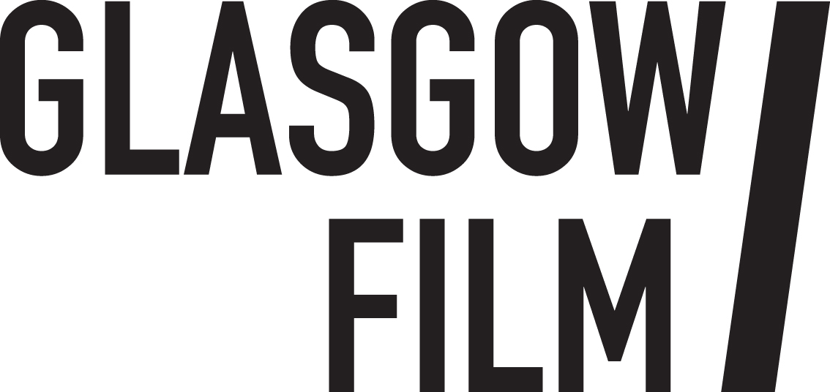

Job Description July 2026: Talent Development Coordinator
The Talent Development Coordinator will play a key role within the Glasgow Film Festival Industry team, supporting the Industry Manager to coordinate and lead on the festival’s growing talent development initiatives. The successful applicant will deliver projects and activities integral to the organisations strategic priority to become the UK’s leading talent development film festival.

The successful candidate will oversee the delivery of our core talent development initiatives by coordinating the year-round programme of activities, managing the lab participants and live pitch events taking place during the festival. They will be required to work closely with the wider team to ensure the smooth and effective operation of talent development projects, ensuring we provide the best possible support to nurture talent for long-term success.

Who are we looking for?

We are seeking an individual who is passionate about nurturing talent in Scotland and the UK. The ideal candidate will have a proven track record in supporting and developing talent, along with excellent interpersonal skills, meticulous attention to detail, and extensive administrative experience. They will also be adept at working with multiple stakeholders and managing competing workloads effectively. This is a fast-paced rewarding role, responsible for managing multiple deadlines and building positive relationships with filmmakers from across the UK.

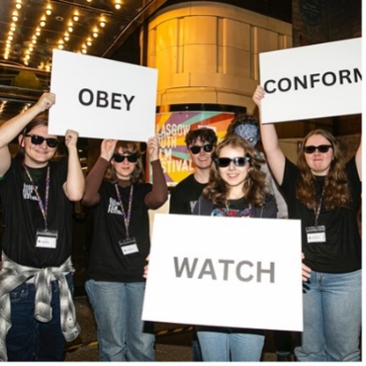

Information for applicants:
July 2026
Dear Applicant,

Thank you for your interest in the post of Glasgow Film Festival Talent Development Coordinator.

In this pack, you’ll find some background information about Glasgow Film, along with more detailed information about the role, a job description, a person specification, and broad terms and conditions.

If you’d like to apply for the post please complete:

- The online application form – Application Form
- The online equal opportunities monitoring form link here

Please refer to the job description and person specification in your application, telling us why you are interested and what skills and experience you would bring to the role.

Please note that, in line with our environmental policy, we are only handling applications electronically. The closing date is Wednesday 15 July at 10am.

We expect to hold in person interviews the week commencing Monday 20 July.

If you need more information before you apply, please contact us by emailing gffcoordinator@glasgowfilm.org.

We look forward to hearing from you and thank you again for your interest.

Best wishes,

Seonaid Daly
CEO
Glasgow Film

About Glasgow Film
Visiting Glasgow Film Theatre feels like stepping into another world. Since 1939 our iconic picture house has been a jewel in the crown of Glasgow’s cultural offering: a purpose-built cinema in the heart of the city, created for the most enthusiastic filmgoers on the planet.
Under the stewardship of Glasgow Film for half a century, our screens show new releases, thematic seasons, rarely screened classics and undiscovered gems, expertly curated by our in-house programming team. Alongside our many programming partners we champion underrepresented filmmakers as well as all-too-often overlooked cinema from around the globe. We have meticulously modernised our film technology whilst honouring our rich cinema heritage and our commitment to the unique craft of 35mm and 70mm film projection. We’ve invested in a world class film-going experience including vital accessibility features to support all audiences and our refurbished art deco interiors make every casual visit feel like an occasion.
As a registered educational charity since 1986, Glasgow Film has evolved from a single screen cinema into a thriving three screen hub of activity where children, families, and young people can learn about film, communities can come together, and filmmakers of the future can develop their careers. In 2024 we celebrated our 50th birthday and held the 20th edition of the renowned Glasgow Film Festival, a legacy that has widened our international reach and helped to nurture our dedicated and diverse film going community that celebrates cinema in all its technicolour (and monochromatic) glory.
We offer something truly special, an inclusive and welcoming space where everyone can nurture their passion for film, delivered by a passionate and knowledgeable team who believe in Cinema for All. We exist to celebrate the magic of film and without us, independent cinema in Scotland would be greatly diminished, losing much of its depth and diversity. People from all walks of life join us to experience films, both new and classic, the way they were meant to be.
Glasgow Film is:
GFT (Glasgow Film Theatre), Glasgow’s original independent cinema.
Glasgow Film Festival (GFF), the UK's second-largest film festival, taking place from 26 February - 9 March 2025.
Glasgow Youth Film Festival (GYFF), our annual youth film festival, co-programmed by a group of Young Programmers aged 15 to 18.
Learning and Youth Opportunities providing children, young people and teachers with the tools and opportunities to get involved in Glasgow’s film culture.
Film Hub Scotland supporting a network of more than 250 film exhibitors serving Scotland's diverse population.

Vision & Mission:
Our vision for Glasgow Film is an inclusive, collaborative space where audiences and communities can nurture their passion for cinema and film and be empowered through participation in our programmes. Everyone is welcome and everyone is included. This is ‘Cinema For All’.
Our mission is to provide 'Cinema For All'. We exist to celebrate the magic of film and nurture excellent independent cinema from across the globe. To do this we provide high-quality programmes of curated screenings, festivals, events and industry opportunities; we empower our communities to participate through education and outreach initiatives; and we develop sector leading equalities initiatives to ensure cinema is accessible, safe and welcoming for the widest possible audience.
Our values are:
Community
This means that we will value, nurture and grow the Glasgow Film community of film fans, staff, supporters, industry and young people. We will have a positive impact in our community and build meaningful relationships with local people and local organisations as well as national and international networks. We will prioritise equality of access and work to tackle the consequences of systemic racism and inequalities that negatively impact the screen sector and fair access to the arts and culture.
Authenticity
This means we are genuine, honest and transparent with our audiences, our stakeholders and with each other as colleagues. We will behave ethically, with purpose, mindfulness and integrity in our everyday activities. We will celebrate our important history and strong identity. We know who we are, and our mission and purpose is clear.
Sustainability
This means we will future proof Glasgow Film for future generations through strong governance, expanding the diversity of our communities and reducing our carbon impact. We will continue to learn how to work more sustainably and imbed good environmental practices across all areas of our organisation.

Equity, Diversity and Inclusion at Glasgow Film
Glasgow Films’ commitment to equity, diversity and inclusion is clearly stated in our vision: Cinema For All. We have a proud history and track record of diverse programming, equalities driven partnership working and developing sector leading equalities initiatives (particularly for disabled audiences). Our flagship initiatives are informed by the views of those with lived experience and we understand that discrimination and inequality affect people in complex ways. Our Equity and Anti-Racism Strategy (led by the Executive) guides our priorities, and our programme and engagement activities play an important part in the success of this strategy.
Information on our community engagement and flagship equalities initiatives can be found here.
Glasgow Film’s commitments in response to Black Lives Matter can be read here.
Glasgow Film organises annual equalities training for staff and volunteers.
Glasgow Film has a Staff and Volunteers Diversity Committee which meets quarterly.

Job Description: Talent Development Coordinator
Terms and Conditions

Employer: Glasgow Film Theatre

Salary: £33,240 per annum

Contract Type: Fixed Term

Term: August 2026 – 26 March 2027

Hours: 35 hours per week on average and as necessary to fulfil the scope of responsibilities within the post. This will involve some weekend and evening work. You will accrue TOIL for additional hours. TOIL needs to be taken back within the contract period i.e. before 26 March 2027, and be agreed with the Industry Manager.

Place of Work: 12 Rose Street, Glasgow

Holidays: 23 days per year plus 8 currently recognised bank/public holidays.

Notice Period: During probation period notice is 1 week, after confirmation of post 1 month for both employer and employee.

Pension: This position will be part of Glasgow Film’s auto enrolment pension plan.

Right to work: The successful applicant must have Right to Work in the UK and will be required to provide documentation under the Immigration, Asylum and Nationality Act 2006.

References: Offers of employment are subject to the receipt of satisfactory employment references. One reference should normally be from your current or most recent employer.

Other benefits: Staff membership benefits (subject to availability): free and reduced priced tickets to Glasgow Film screenings; access to staff screenings; staff rates for hot drinks in café; employee assistance programme; discounted (optional) membership at Hilton DoubleTree Gym and Pool (subject to availability).

Start date: August 2026

Glasgow Film is an Equal Opportunities Employer and as such all positions will be offered to the candidate with the required skills for the post and without consideration to a candidate’s race, ethnic origin, nationality, religion or belief, sex, sexual orientation, gender reassignment, age, marital or civil partnership status or disability.

Job Description: Talent Development Coordinator

Reports to: Industry Manager

Department: Glasgow Film Festival

Staff Structure: Attached

Principal Purpose of the Post

The primary responsibility of the role is to support the Industry Manager in delivering the festival’s expanding year-round talent development programme of events, including development labs, mentorship activities and pitching events. The successful candidate will work closely with the Industry Manager and other members of staff also working on the festival’s talent development initiatives and will oversee the coordination, delivery, reporting, and administrative needs of the programmes across 2026 – 2027.

The successful candidate will be responsible for managing the application processes for all labs, researching and securing facilitators and mentors. They will also coordinate workshops, consultations, and in-person sessions, serving as the primary point of contact for all stakeholders and partners, plus the lab participants. Additionally, they will collate participant reports across all projects, prepare funding reports and provide regular updates to the Industry Manager.

Given the fast-paced nature of this role and the involvement of multiple partners, strong attention to detail, solid administrative experience, and excellent written and verbal communication skills are essential. The successful candidate will be a team player, able to work well under pressure and effectively prioritise tasks. The ability to collaborate with a range of stakeholders is also key.

Responsibilities

- Support and oversee all talent lab workshops, ensuring they are delivered according to the agreed programme guidelines set by the Industry Manager and that project coordinators remain on schedule
- Develop and oversee the online application processes, ensuring that all applications are logged accurately, responded to promptly, and any applicant queries are dealt with in a timely manner
- Act as the main point of contact for all stakeholders, partners and particpants, providing consistent and reliable communication
- Research and secure facilitators and mentors who will deliver against the aims of each talent development initiative
- Monitor and record all expenditure, following company guidelines, ensuring invoices are submitted in a timely manner.
- Across all talent development projects ensure all Festival Databases are kept up to date and key information is being completed in a consistent and timely manner
- Review participant reports provided by the project coordinators and ensure that the Industry Manager receives regular updates
- Prepare reports for the Industry Manager, ensure evaluation and monitoring requirements are being met and draft funder reports
- Liaise with the Festival Marketing Manager to ensure that opportunities are promoted effectively and reach the target audiences
- Act as the main point of contact for the Live Pitches during Industry Focus 2027, working closely with the onsite tech team, project coordinators, and venue coordinators to ensure the smooth running of the event
- Support the Industry Manager and the wider festival team whenever required
- Gather feedback from participants and partners at the conclusion of each project to inform future planning and improvements

Responsibilities for all staff

- Follow Glasgow Film’s Equal Opportunities Policy and uphold our commitments to anti-racism and equalities, helping to nurture an inclusive staff culture.
- Follow Glasgow Film’s Environmental Policy, minimise individual environmental impacts and be committed to ongoing improvements and good practice.

This job description describes the principal purpose and main elements of the job at this time. It is a guide to the nature of the main duties as they currently exist but is not intended to be all-inclusive. The post holder is expected to work flexibly and respond positively to changing business needs.

PERSON SPECIFICATION:
EXPERIENCE & KNOWLEDGE | ESSENTIAL (E)/ DESIRABLE (D)
An understanding on the development of events and projects that underline our commitment to diversity and inclusion | E
An interest in the Scottish Film & TV Sector and knowledge of the talent development landscape in the UK and Europe | E
Relevant event experience with a track record in delivering industry events, talent development labs or in a festival or project coordination role | E
Experience of using Microsoft packages and other database programmes | E
Administration experience, preferably in an arts related environment, and ability to manage and collate large amounts of data | E
An understanding of and clear commitment to anti-racism, equity, diversity and equal opportunities | E
An understanding of environmental and sustainability issues relevant to the role | D
SKILLS AND ABILITIES
Excellent administrative, budgeting and organisational skills | E
Excellent multi-tasking skills, ability to efficiently prioritise work and meet deadlines | E
Excellent verbal and written skills | E
Proactive and hard-working | E
Ability to use computerised systems (word-processing, database, and spreadsheet), with good keyboard skills | E
Excellent collaborator able to work with others to achieve organisation goals | E
PERSONAL QUALITIES AND ATTITUDES
Positive, friendly, empathetic and inclusive | E
A team player | E
Pro-active and motivated | E
Calm and focussed under pressure | E
Committed to quality and attentive to detail | E
Don’t meet every single requirement? Studies have shown that women and those from the Global Majority are less likely to apply to jobs unless they meet every single qualification. We are dedicated to building a diverse, inclusive and authentic workplace, so if you’re excited about this role but your past experience doesn’t align perfectly with every qualification in the job description, we encourage you to apply.

