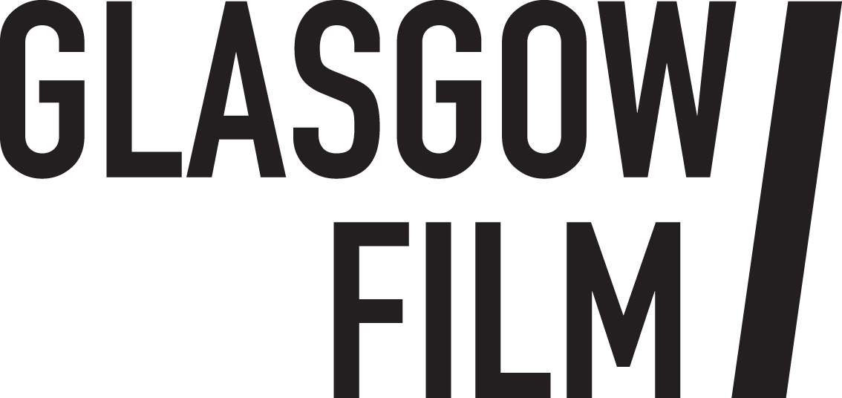

Job Description September 2025: Industry Focus Officer
Glasgow Film Festival (GFF)’s industry conference is a 5-day event that takes place annually each March during the festival. Taking place at Social Hub in the Merchant City area of Glasgow, the conference is a mix of panels, workshops, spotlight in conversations, networking, press and industry screenings.

The successful applicant will support the Industry Manager in the planning and delivery of events that connect and support the Scottish, UK and International filmmaking community. They will be expected to liaise with prospective speakers, identifying their travel and accommodation needs, and coordinate event requirements with the venue. During the conference they will be expected to be working at the venue, as a point of contact for professionals engaged to deliver events, and ensure the venue is set up to requirements. This role must work collaboratively to ensure a smooth and effective operation and provide the best possible support to attending delegates and guests.

Who are we looking for?

The ideal candidate will have a proven track record in planning and delivering events, with excellent communication skills, meticulous attention to detail, plus administrative experience. They will also be adept at managing competing workloads effectively. This is a fast-paced rewarding role, key to continuing GFF’s positive reputation and relationships with screen professionals from across the UK and internationally.

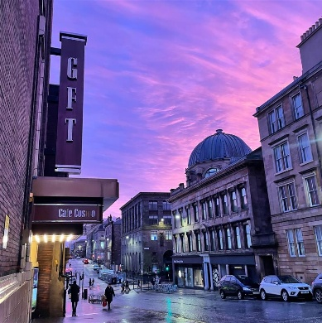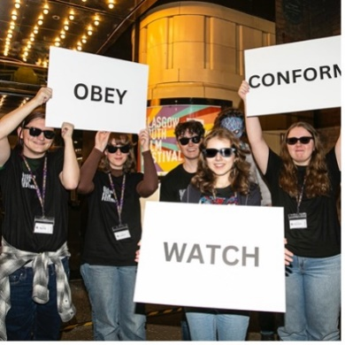

Information for applicants:
September 2025
Dear Applicant,
Thank you for your interest in the post of Industry Focus Officer at Glasgow Film Festival.
In this pack, you will find some background information about Glasgow Film, along with more detailed information about the role, a job description, a person specification, and broad terms and conditions.
If you would like to apply for the post, please complete:
- The online application form here
- The online equal opportunities monitoring form here
Please refer to the job description and person specification in your application, telling us why you are interested and what skills and experience you would bring to the role.Please note that, in line with our environmental policy, we are only handling applications electronically.
The closing date is Monday 6 October at 10am and interviews will be held online w/b Monday 13 October.
We look forward to hearing from you and thank you again for your interest.

Debbie Aitken

Head of Operations for Glasgow Film Festival
Glasgow Film

About Glasgow Film
Visiting Glasgow Film Theatre feels like stepping into another world. Since 1939 our iconic picture house has been a jewel in the crown of Glasgow’s cultural offering: a purpose-built cinema in the heart of the city, created for the most enthusiastic filmgoers on the planet.
Under the stewardship of Glasgow Film for half a century, our screens show new releases, thematic seasons, rarely screened classics and undiscovered gems, expertly curated by our in-house programming team. Alongside our many programming partners we champion underrepresented filmmakers as well as all-too-often overlooked cinema from around the globe. We have meticulously modernised our film technology whilst honouring our rich cinema heritage and our commitment to the unique craft of 35mm and 70mm film projection. We’ve invested in a world class film-going experience including vital accessibility features to support all audiences and our refurbished art deco interiors make every casual visit feel like an occasion.

As a registered educational charity since 1986, Glasgow Film has evolved from a single screen cinema into a thriving three screen hub of activity where children, families, and young people can learn about film, communities can come together, and filmmakers of the future can develop their careers. In 2024 we celebrated our 50th birthday and held the 20th edition of the renowned Glasgow Film Festival, a legacy that has widened our international reach and helped to nurture our dedicated and diverse film going community that celebrates cinema in all its technicolour (and monochromatic) glory.
We offer something truly special, an inclusive and welcoming space where everyone can nurture their passion for film, delivered by a passionate and knowledgeable team who believe in Cinema for All. We exist to celebrate the magic of film and without us, independent cinema in Scotland would be greatly diminished, losing much of its depth and diversity. People from all walks of life join us to experience films, both new and classic, the way they were meant to be.
Glasgow Film is:
GFT (Glasgow Film Theatre), Glasgow’s original independent cinema.
Glasgow Film Festival (GFF), the UK's second-largest film festival, taking place from 26 February - 9 March 2025.
Glasgow Youth Film Festival (GYFF), our annual youth film festival, co-programmed by a group of Young Programmers aged 15 to 18.
Learning and Youth Opportunities providing children, young people and teachers with the tools and opportunities to get involved in Glasgow’s film culture.
Film Hub Scotland supporting a network of more than 250 film exhibitors serving Scotland's diverse population.

Vision & Mission:
Our vision for Glasgow Film is an inclusive, collaborative space where audiences and communities can nurture their passion for cinema and film and be empowered through participation in our programmes. Everyone is welcome and everyone is included. This is ‘Cinema For All’.
Our mission is to provide 'Cinema For All'. We exist to celebrate the magic of film and nurture excellent independent cinema from across the globe. To do this we provide high-quality programmes of curated screenings, festivals, events and industry opportunities; we empower our communities to participate through education and outreach initiatives; and we develop sector leading equalities initiatives to ensure cinema is accessible, safe and welcoming for the widest possible audience.
Our values are:
Community
This means that we will value, nurture and grow the Glasgow Film community of film fans, staff, supporters, industry and young people. We will have a positive impact in our community and build meaningful relationships with local people and local organisations as well as national and international networks. We will prioritise equality of access and work to tackle the consequences of systemic racism and inequalities that negatively impact the screen sector and fair access to the arts and culture.
Authenticity
This means we are genuine, honest and transparent with our audiences, our stakeholders and with each other as colleagues. We will behave ethically, with purpose, mindfulness and integrity in our everyday activities. We will celebrate our important history and strong identity. We know who we are, and our mission and purpose is clear.
Sustainability
This means we will future proof Glasgow Film for future generations through strong governance, expanding the diversity of our communities and reducing our carbon impact. We will continue to learn how to work more sustainably and imbed good environmental practices across all areas of our organisation.

Equity, Diversity and Inclusion at Glasgow Film
Glasgow Films’ commitment to equity, diversity and inclusion is clearly stated in our vision: Cinema For All. We have a proud history and track record of diverse programming, equalities driven partnership working and developing sector leading equalities initiatives (particularly for disabled audiences). Our flagship initiatives are informed by the views of those with lived experience and we understand that discrimination and inequality affect people in complex ways. Our Equity and Anti-Racism Strategy (led by the Executive) guides our priorities, and our programme and engagement activities play an important part in the success of this strategy.
Information on our community engagement and flagship equalities initiatives can be found here.
Glasgow Film’s commitments in response to Black Lives Matter can be read here.
Glasgow Film organises annual equalities training for staff and volunteers.
Glasgow Film has a Staff and Volunteers Diversity Committee which meets quarterly.

Job Description: Industry Focus Officer
Terms and Conditions

Employer: Glasgow Film Theatre

Salary: £27,540 (pro-rata)

Contract Type: Fixed Term

Term: TBC October 2025 – 27 March 2026

Hours: 35 hours per week on average and as necessary to fulfil the scope of responsibilities within the post. This will involve some weekend and evening work. You will accrue TOIL for additional hours. TOIL needs to be taken back within the contract period i.e. before 27 March 2025, and be agreed with the Industry Manager.

Place of Work: 12 Rose Street, Glasgow

Holidays: 23 days per year plus 8 currently recognised bank/public holidays.

Notice Period: During probation period notice is 1 week, after confirmation of post 1 month for both employer and employee.

Pension: This position will be part of Glasgow Film’s auto enrolment pension plan.

Right to work: The successful applicant will be required to provide documentation under the Immigration, Asylum and Nationality Act 2006.

References: Offers of employment are subject to the receipt of references that are satisfactory to Glasgow Film.

Other benefits: Staff membership benefits (subject to availability): free and reduced priced tickets to Glasgow Film screenings; access to staff screenings; staff rates for hot drinks in café; employee assistance programme; discounted (optional) membership at Hilton DoubleTree Gym and Pool (subject to availability).

Start date: October 2025

Glasgow Film is an Equal Opportunities Employer and as such all positions will be offered to the candidate with the required skills for the post and without consideration to a candidate’s race, ethnic origin, nationality, religion or belief, sex, sexual orientation, gender reassignment, age, marital or civil partnership status or disability.

Job Description: Industry Focus Officer

Reports to: Industry Manager

Department: Glasgow Film Festival

Staff Structure: Attached

Principal Purpose of the Post

The primary responsibility of the role is to support the Industry Manager in planning and delivering the festival’s 5-day conference, Industry Focus.

The successful candidate will work closely with the Industry Manager to research and plan the wide scope of events that occur during the conference. This will include but is not limited to; liaising with external venues and suppliers to ensure the smooth delivery of the programme of events, researching and securing speakers or organisations under the guidance and instruction of the Industry Manager, confirming travel and accommodation requirements, identifying potential sponsors for hospitality and networking receptions. The successful candidate will be responsible for managing the schedule of confirmed events during the conference and act as a primary point of contact for programme partners, sponsors and suppliers in the lead up to and during the conference.

They will also be expected to serve as the primary point of contact for industry delegates, in the lead up and during the festival. This includes monitoring the shared industry mailbox, answering any enquiries and providing information to the marketing department around the promotion and programme information of the conference.

An understanding of the film industry is desirable, but you should have a demonstrable track record of curating and delivering large-scale events, preferably in a conference or industry setting. Solid administrative experience and written and verbal communication skills are essential.

Responsibilities

- Support the building of a programme of industry facing events (seminars, panels, meetings, networking, screenings, interviews, hospitality etc) at Industry Focus during Glasgow Film Festival
- Research and secure event sponsors and partners for the Industry Focus programme, this will also include the preparation of sponsorship agreements
- Research and secure national and international industry speakers for the programme and coordinate their visit
- Act as the main point of contact for all Industry guests and partners, providing consistent and reliable communication
- Liaise with the guest and programme team to maximise opportunities during Glasgow Film Festival for Industry Focus
- Confirming all speakers / participants requirements and liaise with the guest team to organise travel and accommodation for visiting Industry guests
- Ensure all relevant festival databases are kept up to date with key industry guests and events
- Ensure all event information is accurately uploaded to the event app, and collaborate with the Database Officer to confirm all pass holders and guests are correctly listed and accessible within the app
- Liaise with the Festival Marketing Coordinator to ensure that the Industry Focus conference is promoted effectively and reaches the target audiences
- Working with the Database Officer to coordinate outreach for Industry Pass sales and support the invoicing process
- During festival, ensure venue coordinators and volunteers are fully briefed on each event and act as a main point of contact for all contractors
- Support the Industry Manager and the wider festival team whenever required
- Gather feedback from participants and partners at the conclusion of each project to inform future planning and improvements

Responsibilities for all staff

- Follow Glasgow Film’s Equal Opportunities Policy and uphold our commitments to anti-racism and equalities, helping to nurture an inclusive staff culture.
- Follow Glasgow Film’s Environmental Policy, minimise individual environmental impacts and be committed to ongoing improvements and good practice.

This job description describes the principal purpose and main elements of the job at this time. It is a guide to the nature of the main duties as they currently exist but is not intended to be all-inclusive. The post holder is expected to work flexibly and respond positively to changing business needs.

PERSON SPECIFICATION:

The successful candidate will be a team player, able to work well under pressure and effectively prioritise tasks. The ability to collaborate with a range of stakeholders is also key.

EXPERIENCE & KNOWLEDGE | ESSENTIAL (E)/ DESIRABLE (D)
An understanding on the development of events and projects that underline our commitment to diversity and inclusion | E
An interest in the Scottish Film & TV Sector and knowledge of the talent development landscape in the UK and Europe | D
A minimum of 2 years’ relevant experience of working in a film, delivering industry events or talent development labs or a festival or project coordination role | D
Experience working with internal and external stakeholders, and developing projects and events | E
Experience of using Microsoft packages and other database programmes | D
Administration experience, preferably in an arts related environment, and ability to manage and collate large amounts of data | E
An understanding of and clear commitment to anti-racism, equity, diversity and equal opportunities | E
An understanding of environmental and sustainability issues relevant to the role | D
SKILLS AND ABILITIES
Excellent administrative and organisational skills, including multi-tasking with the ability to prioritise and meet deadlines | E
Excellent verbal and written communication skills | E
Ability to work in a fast-paced environment and problem solve on the go | D
Ability to use computerised systems (word-processing, database, and spreadsheet), with good keyboard skills | E
Excellent collaborator able to work with others to achieve organisation goals | E
PERSONAL QUALITIES AND ATTITUDES
Positive, friendly, empathetic and inclusive | E
A team player | E
Pro-active and motivated | E
Calm and focussed under pressure | E
Committed to quality and attentive to detail | E
Don’t meet every single requirement? Studies have shown that women and those from the Global Majority are less likely to apply to jobs unless they meet every single qualification. We are dedicated to building a diverse, inclusive and authentic workplace, so if you’re excited about this role but your past experience doesn’t align perfectly with every qualification in the job description, we encourage you to apply.

