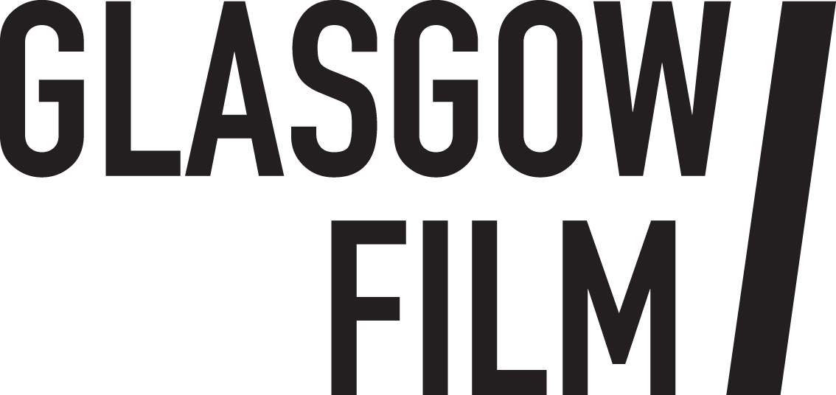

Job Description: People and Culture Coordinator

July 2025
The People and Culture Coordinator plays a key role in supporting the HR and Facilities Manager and other senior staff in the effective delivery of HR operations, staff and volunteer recruitment, learning and development initiatives, and employee and volunteer engagement across the organisation.

Who are we looking for?

We are looking for a proactive and highly organised individual with a passion for people-focused work and a strong commitment to equality, diversity, and inclusion. The ideal candidate will have solid experience in HR administration and volunteer recruitment but be keen to further develop in these areas, they will also have excellent attention to detail, and the ability to handle confidential information with discretion. They will thrive in a collaborative environment, supporting a wide range of activities across the employee and volunteer lifecycle - from onboarding and training to staff engagement and development. A strong communicator and enthusiastic team player, they will help drive forward key initiatives that support Glasgow Film’s values and contribute to a positive, inclusive workplace culture.

This is an exciting new role created to support a growing team and Glasgow Film’s ongoing commitment to nurturing an inclusive and supportive workplace culture. The role is offered initially as an 18-month contract with the potential to become permanent.

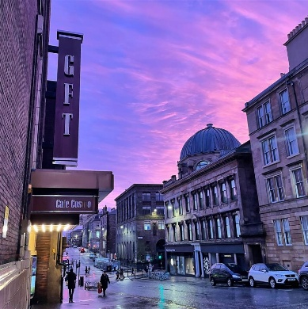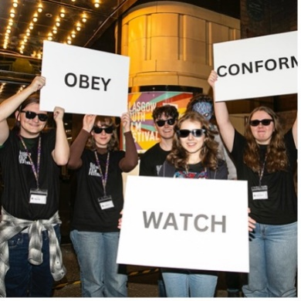

Information for applicants:
July 2025
Dear Applicant,
Thank you for your interest in the post of People and Culture Coordinator at Glasgow Film.
In this pack, you will find some background information about Glasgow Film, along with more detailed information about the role, a job description, a person specification, and broad terms and conditions.
If you would like to apply for the post, please complete the application form and the online equal opportunities monitoring form https://forms.office.com/e/fFN6raViyh . Please refer to the job description and person specification in your application, telling us why you are interested and what skills and experience you would bring to the role.
Please email your completed application form and a short covering letter (no more than 500 words) to vacancies@glasgowfilm.org.
Please note that, in line with our environmental policy, we are only handling applications electronically. The closing date is Thursday 24 July at 10am
We expect to hold interviews on w/b Monday 4 August.
We look forward to hearing from you and thank you again for your interest.
Best wishes,
Seonaid Daly
Executive Director, Glasgow Film
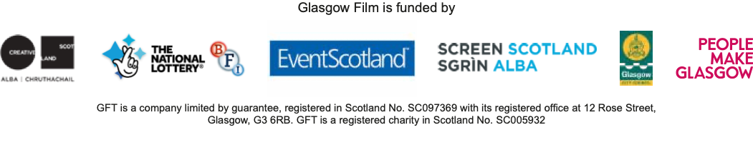

About Glasgow Film
Visiting Glasgow Film Theatre feels like stepping into another world. Since 1939 our iconic picture house has been a jewel in the crown of Glasgow’s cultural offering: a purpose-built cinema in the heart of the city, created for the most enthusiastic filmgoers on the planet.
Under the stewardship of Glasgow Film for half a century, our screens show new releases, thematic seasons, rarely screened classics and undiscovered gems, expertly curated by our in-house programming team. Alongside our many programming partners we champion underrepresented filmmakers as well as all-too-often overlooked cinema from around the globe. We have meticulously modernised our film technology whilst honouring our rich cinema heritage and our commitment to the unique craft of 35mm and 70mm film projection. We’ve invested in a world class film-going experience including vital accessibility features to support all audiences and our refurbished art deco interiors make every casual visit feel like an occasion.
As a registered educational charity since 1986, Glasgow Film has evolved from a single screen cinema into a thriving three screen hub of activity where children, families, and young people can learn about film, communities can come together, and filmmakers of the future can develop their careers. In 2024 we celebrated our 50th birthday and held the 20th edition of the renowned Glasgow Film Festival, a legacy that has widened our international reach and helped to nurture our dedicated and diverse film going community that celebrates cinema in all its technicolour (and monochromatic) glory.
We offer something truly special, an inclusive and welcoming space where everyone can nurture their passion for film, delivered by a passionate and knowledgeable team who believe in Cinema for All. We exist to celebrate the magic of film and without us, independent cinema in Scotland would be greatly diminished, losing much of its depth and diversity. People from all walks of life join us to experience films, both new and classic, the way they were meant to be.

Glasgow Film is:
GFT (Glasgow Film Theatre), Glasgow’s original independent cinema.

Glasgow Film Festival (GFF), the UK's second-largest film festival, taking place from 26 February - 9 March 2025.
Glasgow Youth Film Festival (GYFF), our annual youth film festival, co-programmed by a group of Young Programmers aged 15 to 18.
Learning and Youth Opportunities providing children, young people and teachers with the tools and opportunities to get involved in Glasgow’s film culture.
Film Hub Scotland supporting a network of more than 250 film exhibitors serving Scotland's diverse population.
Vision & Mission:
Our vision for Glasgow Film is an inclusive, collaborative space where audiences and communities can nurture their passion for cinema and film and be empowered through participation in our programmes. Everyone is welcome and everyone is included. This is ‘Cinema For All’.
Our mission is to provide 'Cinema For All'. We exist to celebrate the magic of film and nurture excellent independent cinema from across the globe. To do this we provide high-quality programmes of curated screenings, festivals, events and industry opportunities; we empower our communities to participate through education and outreach initiatives; and we develop sector leading equalities initiatives to ensure cinema is accessible, safe and welcoming for the widest possible audience.
Our values are:
Community
This means that we will value, nurture and grow the Glasgow Film community of film fans, staff, supporters, industry and young people. We will have a positive impact in our community and build meaningful relationships with local people and local organisations as well as national and international networks. We will prioritise equality of access and work to tackle the consequences of systemic racism and inequalities that negatively impact the screen sector and fair access to the arts and culture.

Authenticity
This means we are genuine, honest and transparent with our audiences, our stakeholders and with each other as colleagues. We will behave ethically, with purpose, mindfulness and integrity in our everyday activities. We will celebrate our important history and strong identity. We know who we are, and our mission and purpose is clear.
Sustainability
This means we will future proof Glasgow Film for future generations through strong governance, expanding the diversity of our communities and reducing our carbon impact. We will continue to learn how to work more sustainably and imbed good environmental practices across all areas of our organisation.
Equity, Diversity and Inclusion at Glasgow Film
Glasgow Films’ commitment to equity, diversity and inclusion is clearly stated in our vision: Cinema For All. We have a proud history and track record of diverse programming, equalities driven partnership working and developing sector leading equalities initiatives (particularly for disabled audiences). Our flagship initiatives are informed by the views of those with lived experience and we understand that discrimination and inequality affect people in complex ways. Our Equity and Anti-Racism Strategy (led by the Executive) guides our priorities, and our programme and engagement activities play an important part in the success of this strategy.
Information on our community engagement and flagship equalities initiatives can be found here.
Glasgow Film’s commitments in response to Black Lives Matter can be read here.
Glasgow Film organises annual equalities training for staff and volunteers.
Glasgow Film has a Staff and Volunteers Diversity Committee which meets quarterly.

Job Description: GFT People and Culture Coordinator

Terms and Conditions

Employer: Glasgow Film Theatre

Salary: £31,920

Term: 18-month fixed term contract

Hours: Full time - 35 hours per week
The role may require occasional work outside of normal office hours (evenings and weekends) as GFT’s public programme runs 7 days a week.

Place of Work: 12 Rose Street, Glasgow

Holidays: 23 days per year plus 8 currently recognised bank/public holidays.

Notice Period: During probation period notice is 1 week, after confirmation of post notice period is 1 month for both employer and employee.

Pension: This position will be part of Glasgow Film’s auto enrolment pension plan.

Right to work: The successful applicant will be required to provide documentation under the Immigration, Asylum and Nationality Act 2006.

References: Offers of employment are subject to the receipt of references that are satisfactory to Glasgow Film.

Other benefits: Staff membership benefits (subject to availability): free and reduced priced tickets to Glasgow Film screenings; access to staff screenings; staff rates for hot drinks in café; employee assistance programme; discounted (optional) membership at Hilton DoubleTree Gym and Pool (subject to availability).

Start date: October 2025 (exact start date tba)

Glasgow Film is an Equal Opportunities Employer and as such all positions will be offered to the candidate with the required skills for the post and without consideration to a candidate’s race, ethnic origin, nationality, religion or belief, sex, sexual orientation, gender reassignment, age, marital or civil partnership status or disability.

JOB DESCRIPTION: People and Culture Coordinator

Reports to: HR and Facilities Manager

Department: People and Finance

Staff Structure: See attachment

Principal Purpose of the Post
The People and Culture Coordinator plays a key role in supporting the HR and Facilities Manager and other senior staff in the effective delivery of HR operations, staff and volunteer recruitment, learning and development initiatives, and employee and volunteer engagement across the organisation. This role ensures smooth coordination of people-related processes, promotes a positive and inclusive workplace culture, and contributes to the implementation of strategic initiatives in volunteering, equality, diversity, and fair work. Acting as a key point of contact for staff and festival volunteers, the postholder supports a high-quality employee and volunteer experience aligned with the organisation’s values and goals.

The role requires an organised and positive attitude as well as the ability to multi-task and manage deadlines appropriately. The role may require occasional work outside of normal office hours (evenings and weekends) as GFT/GFF runs 7 days a week.

Key Responsibilities:

HR Operations & Administration
- Support the HR/Facilities Manager in implementing HR policies and administering HR systems
- Maintain accurate HR records, contracts, and databases in compliance with data protection regulations
- Assist with payroll administration and liaison with payroll providers
- Support performance management processes, including appraisals and probation reviews
- Assist with health and safety administration related to people management
- Provide general administrative support to the HR/Facilities Manager and Executive team
Recruitment & Inductions
- Help coordinate the end-to-end recruitment process, including posting job adverts, liaising with hiring managers, and scheduling interviews
- Support efforts to attract diverse talent in line with organisational values
- Help coordinate the onboarding processes for new starters, ensuring a smooth induction experience
- Coordinate offboarding procedures for leavers, including exit interviews and related administration
Learning & Development
- Assist in delivering and coordinating the organisation’s Learning and Development strategy
Help identify training needs and development opportunities through staff feedback and research
- Design and deliver staff inductions and HR-related training sessions
- Coordinate training logistics, including scheduling, communication, and tracking attendance
- Maintain the training and development tracker and promote a culture of continuous learning
- Support quarterly Staff and Volunteer Sessions and forums, including scheduling and organising guest speakers
Equality, Diversity, Inclusion (EDI) & Fair Work
- Coordinate the Staff and Volunteer Diversity Committee and support the delivery of its actions
- Contribute to the implementation of the Anti-Racism and Equity strategy, supporting cross-departmental projects
- Develop and manage internal EDI communication platforms, such as the EDI Teams channel
- Support delivery and monitoring of Fair Work Action Plan initiatives, including the Great Place to Work surveys
- Assist with data collection and reporting for internal and external equalities monitoring
Volunteer Coordination
- Collaborate with the GFT Duty Management team to enhance the GFT volunteering programme
- Design and play a hands-on role delivering an integrated GFF volunteer experience, widening recruitment outreach
- Process GFF volunteer applications, shortlist candidates, and support onboarding and training of volunteers
- Coordinate health and safety briefings, gather volunteer feedback, and evaluate programme outcomes
Internal Communications & Engagement
- Assist in delivering internal communications related to people initiatives and employee engagement
- Collaborate with the Executive team on wellbeing and engagement programmes and events

Handling Confidential Information
- Handle all sensitive employee information with confidentiality and discretion
Other Duties
- Support compliance with employment legislation and internal policies
- Attend relevant training and be proactively committed to your own professional development
- Contribute to the organisation’s commitments to Equalities, Diversity, Environmental Sustainability, and continuous improvement
- Participate in company meetings, events, and relevant training as required
- Carry out any other duties reasonably assigned by the HR/Facilities Manager or Executive team
This job description describes the principal purpose and main elements of the job at this time. It is a guide to the nature of the main duties as they currently exist but is not intended to be all-inclusive. The postholder is expected to work flexibly and respond positively to changing business needs.

EXPERIENCE & KNOWLEDGE | ESSENTIAL (E)/ DESIRABLE (D)
Experience of working in a professional team environment | E
Experience supporting HR functions including recruitment, onboarding, training and employee lifecycle administration | E
Relevant HR or Learning qualification (e.g., Level 3 Award in Education and Training or equivalent) | E
Experience coordinating learning and development initiatives, including organising training sessions | E
Experience working with volunteers or in a volunteer management role | E
Understanding of and clear commitment to anti-racism, equity, diversity, and equal opportunities | E
Experience in dealing with and managing personal and confidential information | E
Experience using HR information systems and MS Office tools (Outlook, Excel, Teams, Google Docs) | E
Understanding of employment law, Fair Work practices, and health and safety in people management | D
An understanding of environmental and sustainability issues and commitment to assisting Glasgow Film in reducing its carbon footprint | D
SKILLS AND ABILITIES
Excellent administrative and organisational skills with good attention to detail. | E
Strong communication and interpersonal skills, able to engage effectively with staff, volunteers, and senior management | E
Confident in delivering training and facilitating learning sessions | E
Able to work on own initiative and to manage multiple tasks, prioritise, and meet deadlines | E
Digital literacy and confident use of HR systems, data tracking tools, and virtual collaboration platforms | E
PERSONAL QUALITIES AND ATTITUDES
Passion for people development and creating positive workplace cultures | E
Positive, friendly, empathetic and inclusive | E
Flexible and open minded | E
Pro-active and motivated | E
Calm and focussed under pressure | E
Tactful, diplomatic and a supportive colleague | E
Don’t meet every single requirement? Studies have shown that women and those from the Global Majority are less likely to apply to jobs unless they meet every single qualification. We are dedicated to building a diverse, inclusive and authentic workplace, so if you’re excited about this role but your past experience doesn’t align perfectly with every qualification in the job description, we encourage you to apply.

